

**Tribhuvan University**

**Faculty of Humanities and Social Science**

**Tourism Management System (TravelMate)**

**A PROJECT REPORT**

**Submitted to**

Department of Computer Application

Itahari Namuna College

*In partial fulfillment of the requirements for the degree of Bachelor’s in computer application.*

**Submitted By**

Sagun Basnet

Bhanu Bhakta Khatiwada

**Under the Supervision of**

Er. Chandra Prasad Acharya



**Tribhuvan University**



**Faculty of Humanities and Social Sciences Itahari Namuna College**

# Supervisor’s Recommendation

I hereby recommend that this project prepared under my supervision

By the group (Sagun Basnet and Bhanu Bhakta Khatiwada) entitled

**“TOURISM MANAGEMENT SYSTEM” (TRAVELMATE)** in partial fulfilment of the requirements for the degree of bachelor’s in computer application are recommended for the final evaluation.

Er. Chandra Prasad Acharya

Project Supervisor

Itahari Namuna College

Itahari-8, Sunsari



**Tribhuvan University**



**Faculty of Humanities and Social Sciences Itahari Namuna College**

# Letter of Approval

Thisis tocertify that this project prepared by Sagun Basnet and Bhanu Bhakta Khatiwada entitled **“TOURISM MANAGEMENT SYSTEM”** in partial fulfilment of the requirements for the degree of bachelor’s in computer application has been evaluated. In our opinion it is satisfactory in the scope and quality as a project for the required degree.

Chandra prasad acharya

Supervisor

Itahari Namuna College

Internal Examiner

Itahari Namuna College

Nabin Shrestha

HOD/Coordinator

Itahari Namuna College

External Examiner

Tribhuvan University

# Acknowledgement

The success and final outcomes of this project require a lot of guidance and assistance from many people and are very fortunate to have this all through the completion of this project. We would like to express our gratitude and appreciation to all those who gave us the possibility to complete this project. We are very glad to express our deepest sense of gratitude and sincere thanks to our supervisor Er. Chandra Prasad Acharya and project teacher Mr. Saman KC whose contribution in simulating suggestions and encouragement helped us in completing our project.

We are also thankful to Mr. Nabin Shrestha, HOD, Itahari Namuna College and Mr.

Dharma Neupane, Principal, Itahari Namuna College for encouraging and guiding us throughout the completion of this project. All useful suggestions for this whole work and co-operative behaviour are sincerely acknowledged.

Last but not the least, many thanks go to our teachers, friends, guardians who directly or

indirectly helped us in achieving the goal. We would like to appreciate all the guidance and support which helped in the completion of this project. Special thanks to their comment and advice.

# Abstract

The tourism management system is a comprehensive software solution designed to streamline and enhance various aspects of the tourism industry. It provides a centralized platform that facilitates efficient management of tourism-related activities, such as bookings, reservations, customer interactions, and administrative tasks. The abstract of the tourism management system can be summarized as follows:

The tourism management system aims to improve the overall operational efficiency and customer experience in the tourism industry. It incorporates various modules and functionalities to automate and simplify different processes involved in tourism management.

Overall, the tourism management system aims to streamline operations, enhance customer satisfaction, and drive business growth in the dynamic and competitive tourism industry. By automating processes, centralizing data, and providing valuable insights, the system empowers tourism businesses to deliver exceptional experiences and achieve operational excellence.

[Tourism management system, Tourism industry, Automation, Operational efficiency]

table of contents

Supervisor’s Recommendation ii

Letter of Approval iii

Acknowledgement iv

Abstract v

Chapter 1: Introduction 11

1.1 Introduction 11

1.2 Problem Statement 11

1.3 Objectives 11

1.4 Scope and Limitations 12

1.4.1 Scope 12

1.4.2 Limitation 12

1.5 Report Organization 13

1.6 Assignment of Roles and Responsibilities 14

Chapter 2: Literature Review 15

2.1 Background Study 15

2.2 Literature Review 15

Chapter 3: System Analysis and Design 17

3.1 System Analysis 17

3.1.1 Requirement Analysis 18

3.1.2 Feasibility Analysis 20

3.1.3 Data Modelling (ER Diagram) 22

3.1.4 Process Modelling (DFD) 23

3.2 System Design 27

3.2.1 Architectural Design 27

3.2.2 Database Schema Design 28

3.2.3 Interface Design 29

3.2.4 Software Design 33

Chapter 4: Implementation and Testing 37

4.1 Implementation 37

4.1.1 Tools Used 37

4.1.2 Implementation Details of Modules 38

4.2 Testing 38

4.2.1 Test Cases for Unit Testing 39

4.2.1 Test Cases for System Testing 41

Chapter 5: Conclusion and Future work 42

5.1 Lesson Learnt / Outcome 42

5.2 Conclusion 42

5.3 Future Recommendations 42

References 43

Appendices 44

Appendix 1: Screenshots 44

Appendix 2: Source Codes 47

Appendix 3: Database Table 54

**List of Figures**

Figure 3.1: Waterfall model 17

Figure 3.2: Use case digram 19

Figure 3.3: Gantt chart 21

Figure 3.4: ER Digram 22

Figure 3.5: Context Diagram 23

Figure 3.6: Level 1 DFD 24

Figure 3.7.1: Admin Level 2 DFD 25

Figure 3.7.2: Guide Level 2 DFD 25

Figure 3.7.3: Tourist Level 2 DFD 25

Figure 3.8: Architectural Diagram 27

Figure 3.9: Database Schema 28

Figure 3.10.1: Login Page Design 29

Figure 3.10.2: Admin Home Page Design 29

Figure 3.10.3: Guider Home Page Design 20

Figure 3.10.4: User Registration Page Design 20

Figure 3.10.5: User Detail Page Design 21

Figure 3.10.6: Guider Detail Page Design 21

Figure 3.10.7: Package Detail Page Design 22

Figure 3.10.8: Book Page Design 22

Figure 3.11.1: Login Sequence diagram 33

Figure 3.11.2: Admin Sequence diagram 24

Figure 3.11.3: Guide Sequence diagram 24

Figure 3.11.4: Toutist Sequence diagram 25

Figure 3.12: Activity diagram 36

**List of Tables**

**Test Case Table**

Test Cases Table 1………………………………………………………………………29

Test Cases Table 2………………………………………………………………………31

**Database Table**

Table 1: User …………………………………………………………………………….43

Table 2: Packages………………………………………………………………………...43

Table 3: booking ….……………………………………………………………...............43

Table 4: booked ……………………………………………………………………….....43

Table 5: Review ………………………………………………………………………….43

**List of Abbreviations**

**CSS:** Cascading Style Sheets

**DFD:** Data Flow Diagram

**ER:** Entity Relationship

**HTML:** HyperText Markup Language

**IDE:** Integrate Development Environment

**JS:** JavaScript

**TC Id:** Test Case Id

**UI:** User Interface

# Chapter 1: Introduction

## 1.1 Introduction

Travel Mate is a tourism website that offers a one-stop-shop for all your travel needs. Our website is designed to provide comprehensive information on top tourist destinations, hotels, flights, and other travel-related services. Whether you are planning a romantic getaway, a family vacation, or an adventure-packed trip, Travel Mate has got you covered. With our user-friendly interface and expert recommendations, you can easily plan your dream vacation and create unforgettable memories. Trust us to be your ultimate travel companion and let Travel Mate take you on the journey of a lifetime.

## 1.2 Problem Statement

· Many tourism management systems face challenges in handling booking and reservation processes effectively. Issues such as double bookings, inaccurate availability information, and difficulties in modifying or canceling reservations can negatively impact customer satisfaction and result in revenue loss.

· The existing tourism management systems often suffer from a lack of centralized information. This leads to difficulties in accessing and updating tourist-related data, resulting in inefficient processes and delays in providing accurate information to tourists.

· Effective inventory management is crucial for tourism businesses, including hotels, tour operators, and rental services. However, many tourism management systems lack robust inventory management features, resulting in challenges such as overbooking, underutilization of resources, and difficulty in managing stock levels.

## 1.3 Objectives

There are some objectives of this project:

* To offer a comprehensive database of destinations, activities, and accommodation options, providing travelers with reliable and relevant information to make informed decisions.
* To create an efficient and streamlined booking process that saves travelers time and reduces the risk of errors or mistakes.
* To promote sustainable tourism practices by offering eco-friendly options and educating travelers on sustainable tourism practices.
* To enhance the overall travel experience by providing personalized itineraries, recommendations, and social features to connect with other travelers and share experiences.

## 1.4 Scope and Limitations

### 1.4.1 Scope

This web-based application will overcome the manual approach of managing Tourist and their destination

Admin:

· Add Guide

· Manage Guide

· Upload Packages

· Manage packages

· Track booking/booked packages

Guide:

· upload packages

· Manage Packages

Tourist:

* Booked packages.
* Cancel Booking
* visit site

Our proposed system has the following advantages:

· User friendly interface. · Fast access to database. · More storage capacity. · Search facility.

· Quick booking.

### 1.4.2 Limitation

· Guiders cannot register themselves in this system.

· It requires internet to use it.

## 1.5 Report Organization

The report consists of five chapters in which all the phased of application design and

development will be covered.

Chapter 1: The chapter introduces the system and the problems, gives an overview

about the study.

Chapter 2: The second chapter covers background study and the literature review of the

project.

Chapter 3: The third chapter covers the system analysis and design phase of the

application. It explains the methodology used while developing the system.

Chapter 4: The fourth chapter discuss about the implementation and testing phase of

the application development.

Chapter 5: The last chapter that is the fifth chapter covers the conclusion,

recommendations, and future works to improve this project.

## 1.6 Assignment of Roles and Responsibilities

Brief profiles of each team member and their general duties follow below. Many of the

responsibilities will be shared among team members to ensure the overall success of the project.

**-** **Bhanu Bhakta Khatiwada** will be involved in interactions with the users for requirement determinations. He will help with the physical design of pages and contents. He will also help with coding and testing of the system. He will collect the facts and figures required for improvement of the system.

**-** **Sagun Basnet** will mostly be involved in writing codes for the program. He will

analyses the requirements, facts and figures collected by his team member and implements them in the system. He will design the required prototypes of the system. He will implement the database into a program using programming languages. He plays the main role while designing a user interface.

Both members may work on the same files/tasks at the same time.

# Chapter 2: Literature Review

## 2.1 Background Study

Travel Mate, a tourism web application, would aim to provide users with a comprehensive tool for planning and organizing their travel experiences. Users would be able to search for destinations, view detailed information about attractions and accommodations, create itineraries, and book their travel arrangements. The application would leverage the latest technologies and data sources to provide users with personalized recommendations and insights, as well as real-time information about local events, weather, and other relevant factors. Overall, the tourism web application would strive to be a one-stop-shop for travelers, offering them a seamless and engaging experience from start to finish.

## 2.2 Literature Review

There are several web applications that manage the Tourism industry. Among them Expedia.com is one of them. Expedia is also one of the most popular websites that most of the tourist visited this website.

Expedia is a well-known online travel agency that offers a wide range of travel services to customers all over the world. The company was founded in 1996 and has its headquarters in Bellevue, Washington.

Expedia's website and mobile app allow customers to book flights, hotels, rental cars, vacation packages, and activities, all in one place. Customers can search for and compare travel options, as well as read reviews from other travelers to make informed decisions about their travel plans.

Expedia also has a loyalty program called Expedia Rewards, which allows members to earn points on their bookings and redeem them for travel rewards such as free hotel nights, flight upgrades, or other perks. Members also receive exclusive deals and offers.

In addition to its own offerings, Expedia has partnerships with airlines, hotels, and other travel companies, which allows them to offer customers a wider range of options for their travel needs.

Expedia's customer service team is available 24/7 to assist customers with any questions or issues that they may have. They also offer a flexible cancellation policy, with different rules depending on the booking type [1].

Some of the features of Expedia are:

• **Comprehensive Travel Booking**: Expedia offers a wide range of travel services, including flights, hotels, rental cars, vacation packages, and activities, all in one place. This makes it easy for travelers to plan and book their entire trip with just a few clicks.

• **Flexible Payment Options**: Expedia offers a range of payment options, including credit cards, debit cards, PayPal, and more. Customers can choose the payment option that works best for them.

• **Expedia Rewards**: Expedia has a loyalty program called Expedia Rewards, which allows members to earn points on their bookings and redeem them for travel rewards such as free hotel nights, flight upgrades, or other perks. Members also receive exclusive deals and offers.

• **Customer Service**: Expedia has a customer service team that is available 24/7 to assist customers with any questions or issues that they may have. Customers can contact them via phone, email, or chat.

• **Reviews and Ratings**: Expedia provides reviews and ratings from other travelers for hotels, flights, and activities. This allows customers to make informed decisions about their travel plans based on the experiences of others.

• **Exclusive Deals**: Expedia offers exclusive deals and discounts to its customers, including last-minute deals, package deals, and more.

Overall, Expedia is a popular choice for travelers looking to book flights, hotels, rental cars, and other travel services. Their website and app are user-friendly, and their partnerships with other travel companies allow customers to find and book the best travel options for their needs.

.

# Chapter 3: System Analysis and Design

## 3.1 System Analysis

It mainly focuses on designing, developing and testing high quality software. It helps to produce. high-quality software for the user’s expectation, reaches within times. We are going to use a waterfall model to build this project. It is also known as a linear-sequential lifecycle model. The Waterfall model is the earliest SDLC approach that was used for software development. In this model, each phase must be completed before the next phase can begin and there is no overlapping in the phases. For this project we have clear and fixed requirements, well-understood technology to build this project and this model is easy to understand so, we are using this model to build this project [2].

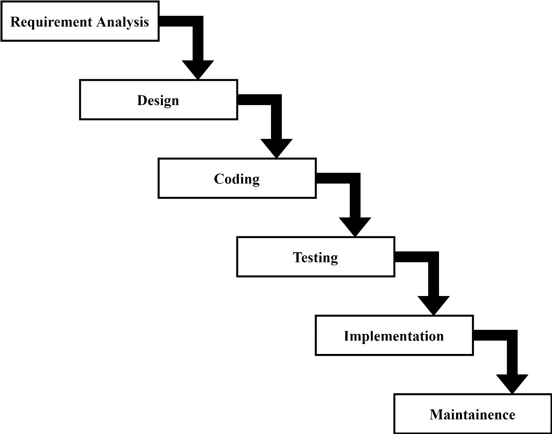

**Figure 3.1: Waterfall model**

### 3.1.1 Requirement Analysis

For any system, there are functional and non-functional requirements to be considered.

while determining the requirements of the system. Functional requirements are product features or functions those developers must implement to enable users to accomplish their tasks. And Non-functional Requirements (NFRs) define system attributes such as security, reliability, performance, maintainability, scalability, and usability.

**I. Functional Requirements**

Only authentic users must have access to the system.

Guider and Admin:

Guider must be authenticated before accessing system.

The Guider will be able to:

· Add/Update/Delete packages

· Check/manage Booking details

· View packages

· Search packages

Admin will also be able to Add/Manage Guider and also be able to update/delete users.

Tourist (Users):

Tourist must be authenticated before accessing system

The Tourist will be able to:

* Search Packages
* View packages details
* Book/cancel package
* Online payment

The use case diagram, which presents the system requirements, is used to show how the proposed system work in practice. The interaction between actor and use cases are also described using use case diagram.

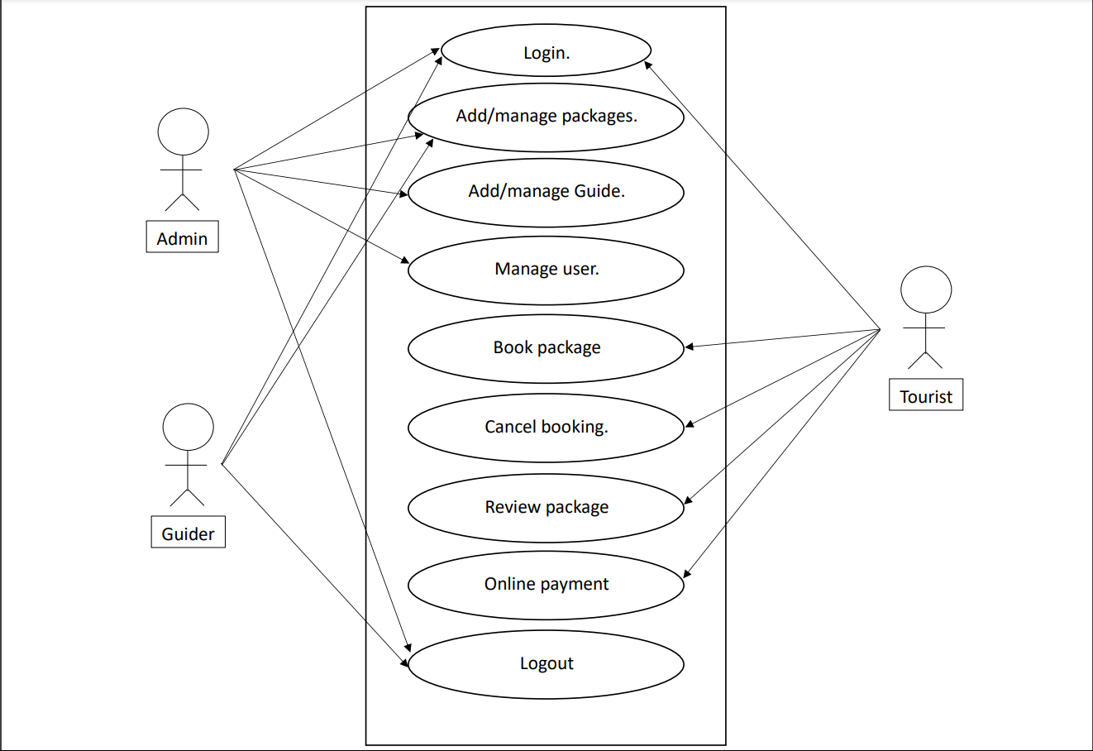

**Figure 3.2: Use case digram**

**II. Non-Functional Requirements**

**Security:** The system can only be accessed after login. Users can login with username and

password.

**Usability:** The system will be user-friendly. The UI should be simple enough for everyone

to.

**Accuracy:** The data stored about the books and the members should be correct, consistent, and reliable.

**Availability:** The System should be available for the duration when the library operates and responds to the requests as soon as possible.

**Maintainability:** The software should be easily maintainable and adding new features and making changes to the software must be as simple as possible.

**Portability:** The software should function properly on multiple environments/devices.

### 3.1.2 Feasibility Analysis

A feasibility study is a detailed analysis that considers all the critical aspects of a proposed project to determine the likelihood of it succeeding. A feasibility analysis is used to determine the viability of an idea, such as ensuring a project is legally and technically feasible as well as economically justifiable. It tells us whether a project is worth the investment—in some cases, a project may not be doable.

Feasibility studies undergo four major analyses to predict the system to be success and they

are as follows:

· Technical Feasibility

· Operational Feasibility · Economic Feasibility · Schedule Feasibility

**I. Technical Feasibility**

This study is carried out to check the technical requirements of the system. We can strongly

say that it is technically feasible, since there will not be much difficulty in getting required resources for the development and maintaining the system as well. All the resources needed for the development of the software are easily collected.

**II. Operational Feasibility**

The system is easy to operate with the basic knowledge of computation and internet. Well trained manpower is not necessary. Users can easily access the system as it is user friendly in many aspects with good UI.

**III. Economic Feasibility**

Development of this application is highly economically feasible. The organization need not

must spend too much money for the development of the system. The only thing to be done is to make an environment for the development of the system in comfortable environment.

**IV. Schedule Feasibility**

The schedule feasibility shows the estimated time to complete the project. This includes the schedules of each process in a project and the total project time. This system that we developed is schedule feasible as it doesn’t require more time for the development phase. A Gantt chart is used for planning projects of all sizes, and it is a useful way of showing that work is scheduled to be done on a specific day. It can also help you to view the start and end dates of a project in one simple chart.

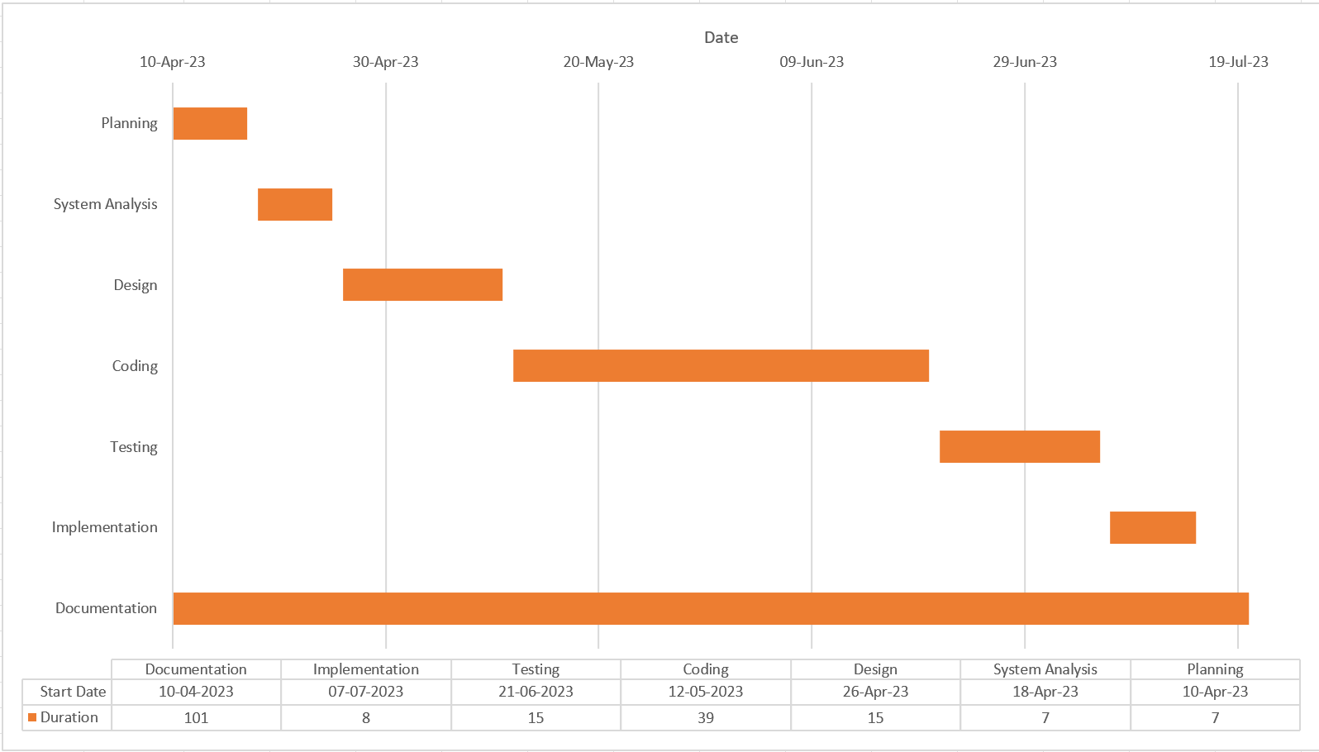

**Figure 3.3: Gantt chart**

### 3.1.3 Data Modelling (ER Diagram)

This ER (Entity Relationship) diagram represents the model of this project (Toursim

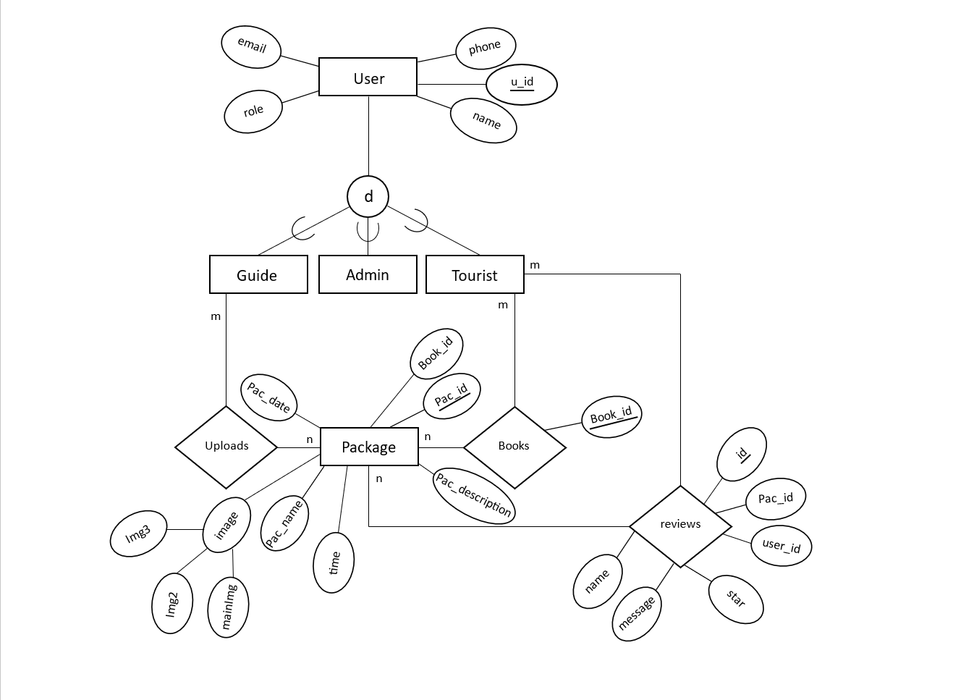Management System).

**Figure 4: ER Diagram**

**Figure 3.4: ER Digram**

### 3.1.4 Process Modelling (DFD)

**Figure 3.5: Context Diagram**

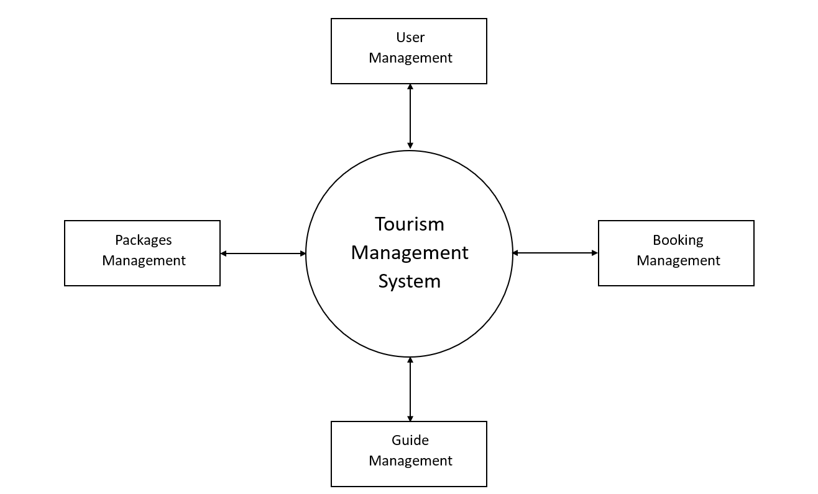

Process modelling involves graphically representing the processes, or actions, that capture,

manipulate, store, and distribute data between a system and its environment and among components within a system. A common form of a process model is a data-flow diagram (DFD)**.** A data-flow diagram is a graphic that illustrates the movement of data between external entities and the processes and data stores within a system.

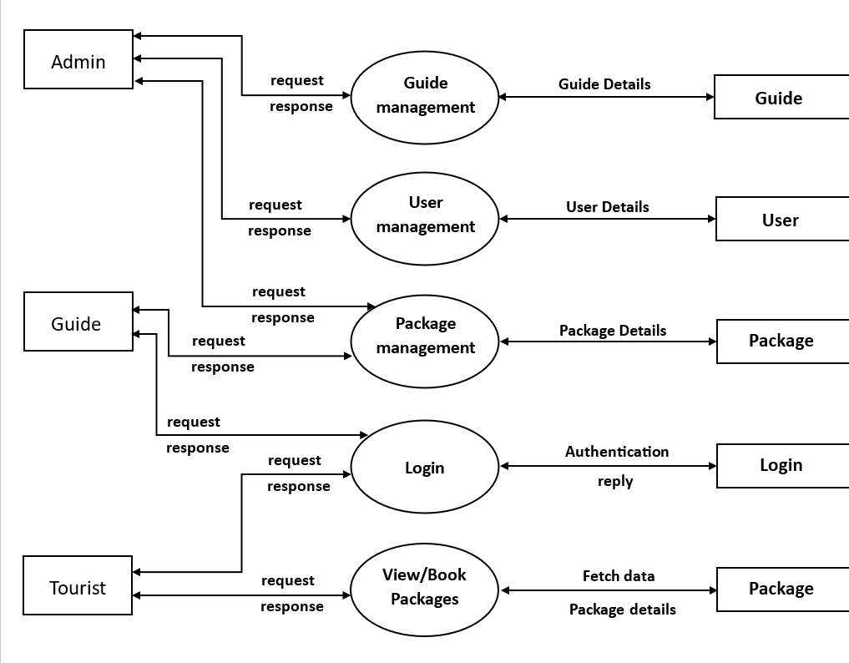

**Figure 3.6: Level 1 DFD**

­­

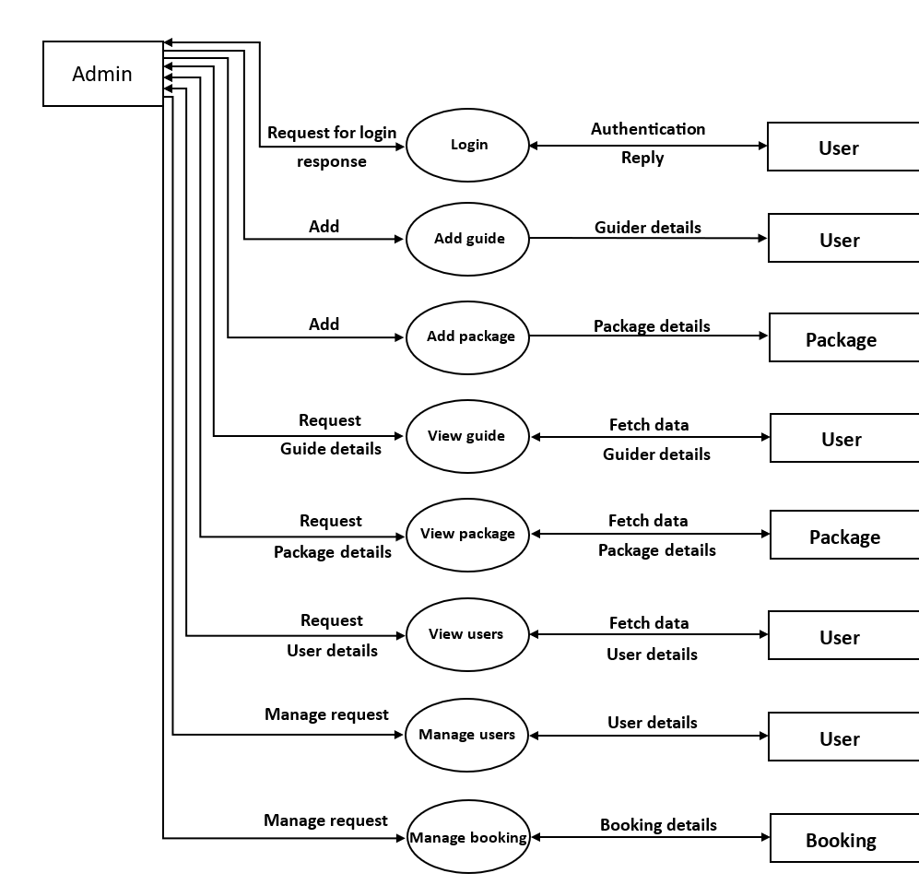

**Figure 3.7.1: Admin Level 2 DFD**

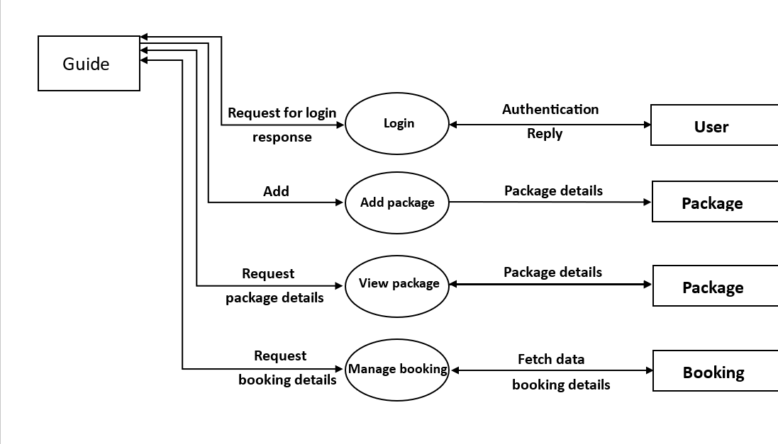

**Figure 3.7.2: Guide Level 2 DFD**

1

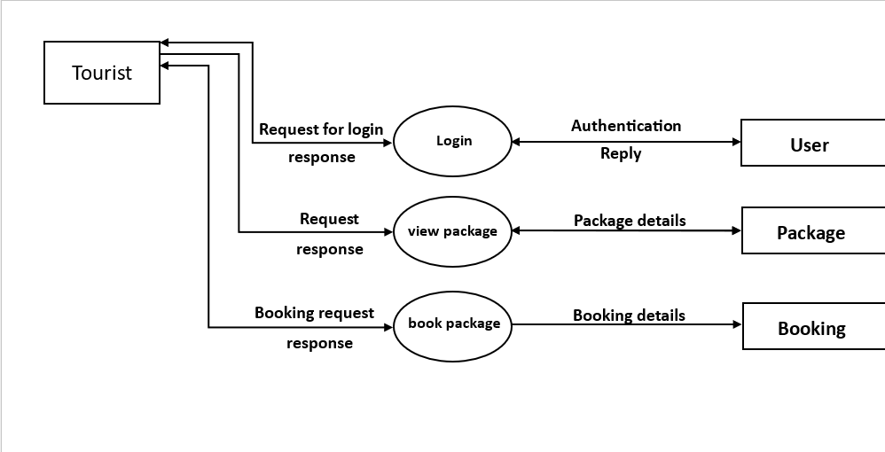

**Figure 3.7.3: Tourist Level 2 DFD**

## 3.2 System Design

System Design is the process of defining the elements of a system such as the architecture, modules and components, the different interfaces of the component and the data that goes through the system. System design gives the knowledge of the requirements and analysis to design the software product. It is meant to satisfy the needs and requirements of a business or organization through the engineering of a coherent and well-running system. In this chapter we will be dealing with the module, database design, user interface design and the program design. For the designing of the application, various diagrams like sequence diagram, activity diagram etc. have been used.

### 3.2.1 Architectural Design

An architectural diagram is a visual representation that maps out the physical

implementation for components of a software system.

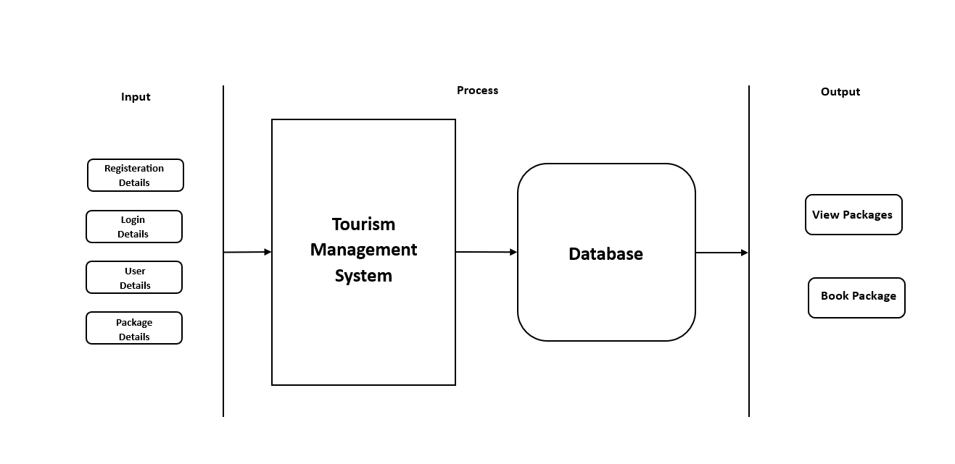

**Figure 3.8: Architectural Diagram**

### 3.2.2 Database Schema Design

The design of the database is called schema. This tells us about the structural view of the database [3]. A database schema represents the logical configuration of all or part of a relational database. A database schema indicates how the entities that make up the database relate to one another, including tables, views, stored procedures, and more. Typically, a database designer creates a database schema to help programmers whose software will interact with the database.

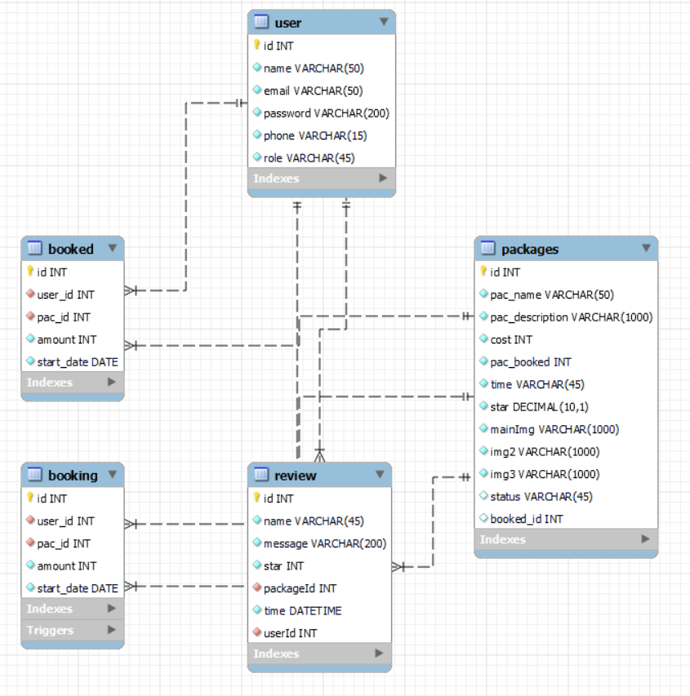

**Figure 3.9: Database Schema**

### 3.2.3 Interface Design

Interface design is an important part of software development. User interface is the front-end application view to which user interacts to use the software. Users can manipulate and control the software as well as hardware by means of user interface. UI should be as simple as possible.

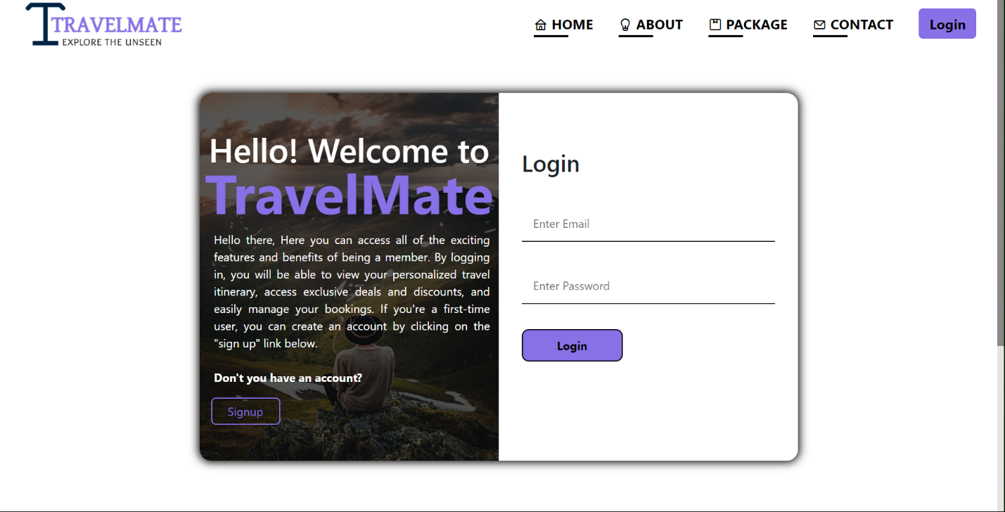

**Figure 3.10.1: Login Page Design**

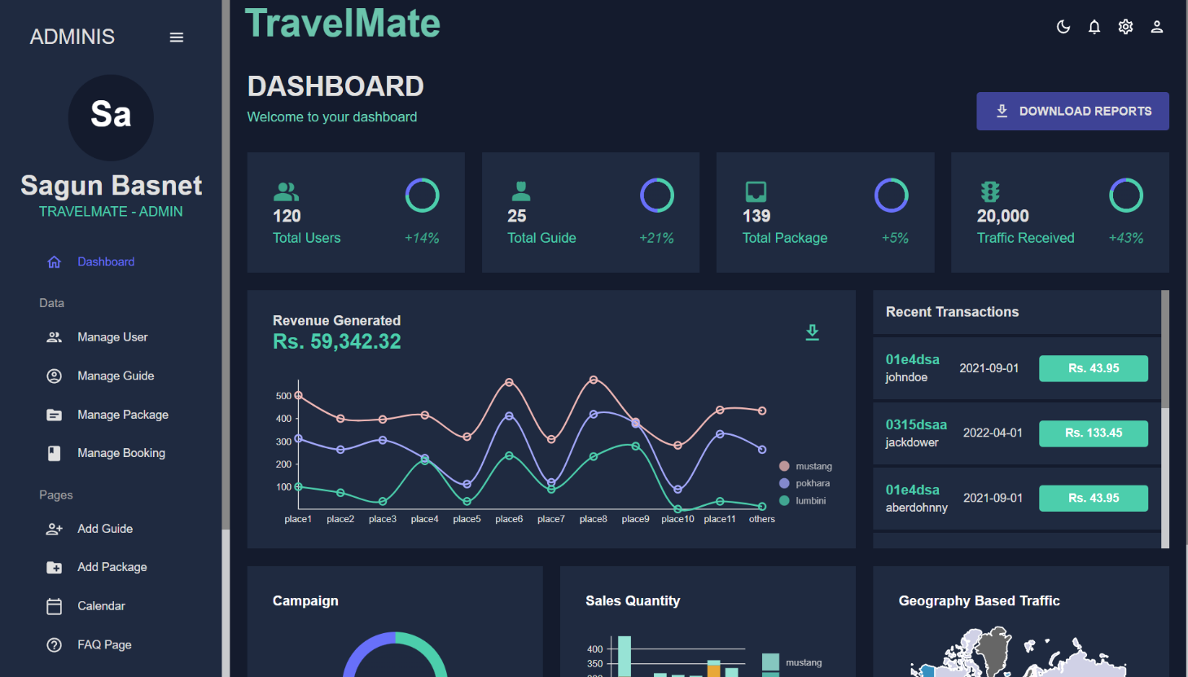

**Figure 3.10.2: Admin home page design**

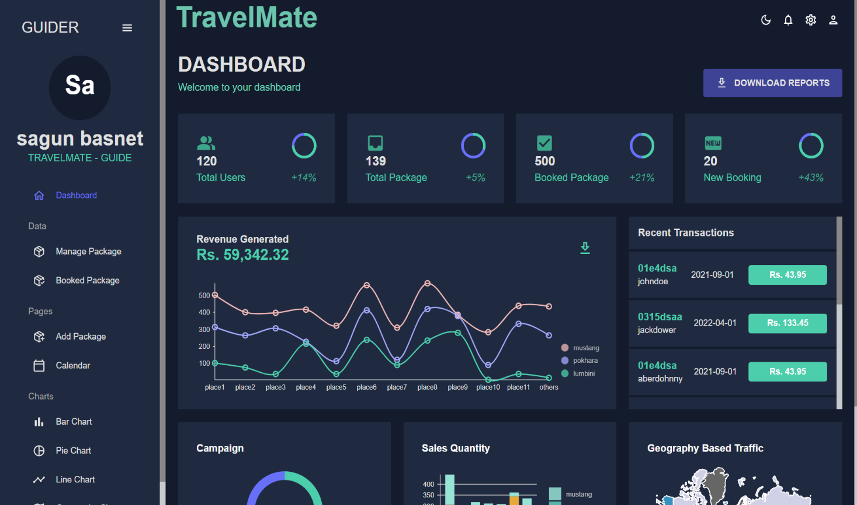

**Figure 3.10.3: Guide home page design**

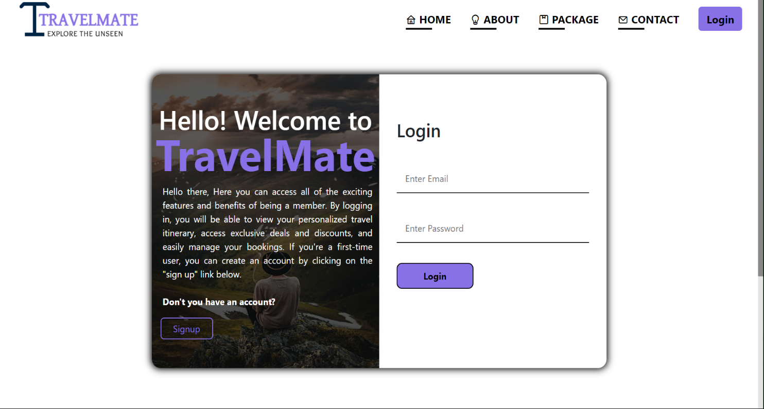

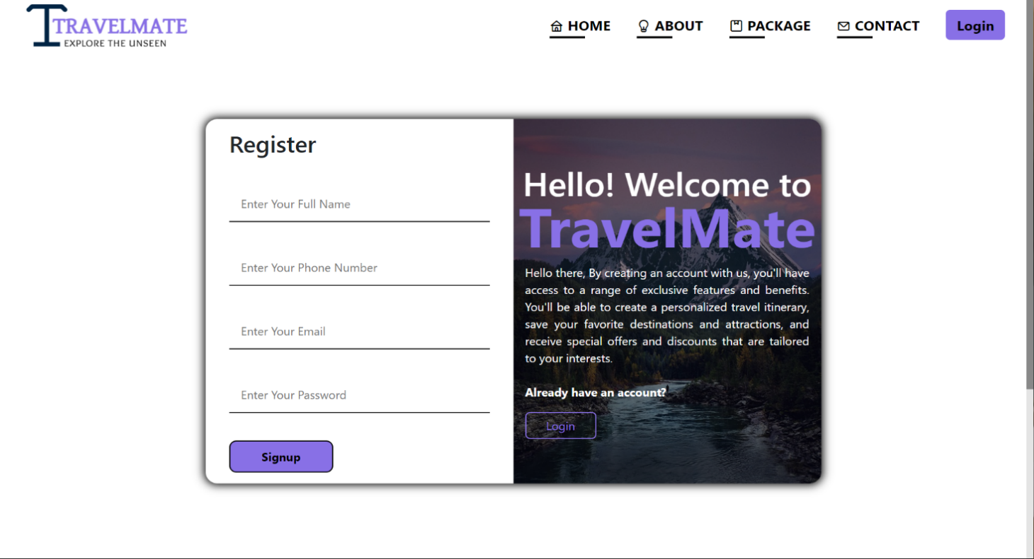

**Figure 3.10.4: User registration page design**

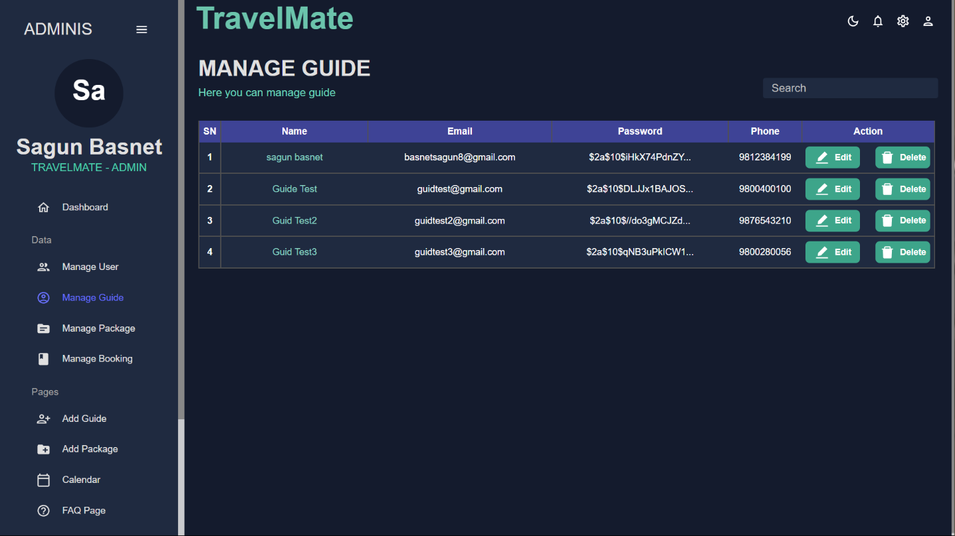

**Figure 3.10.6: Guider detail page design**

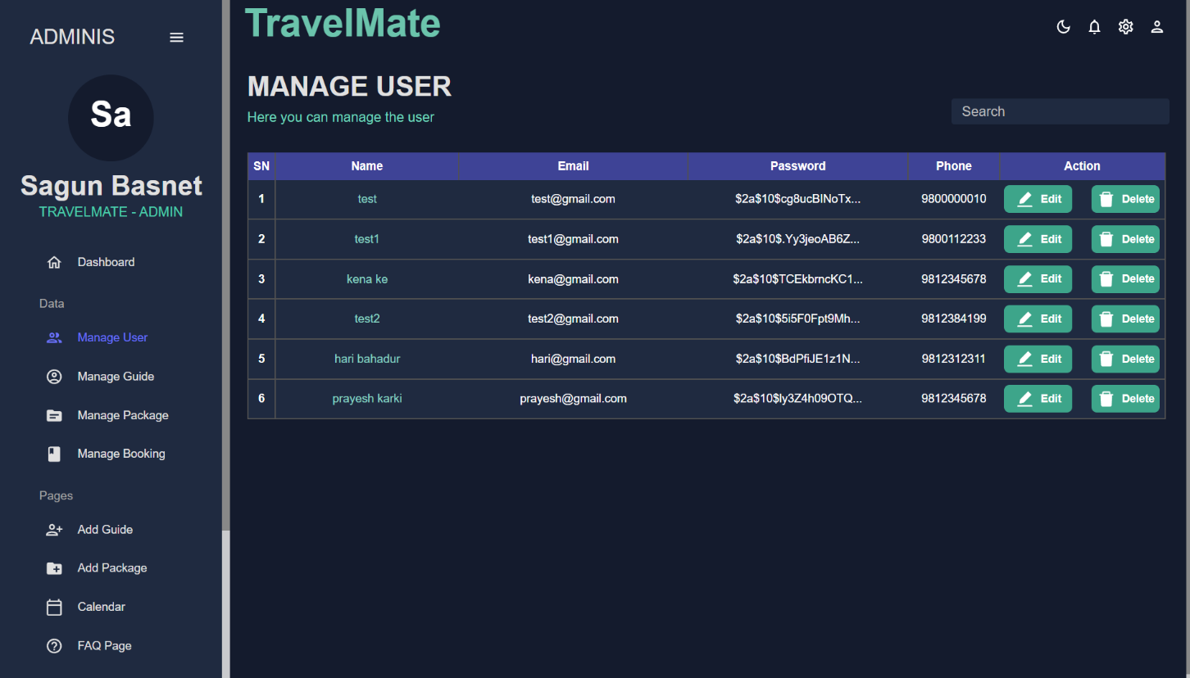

**Figure 3.10.5: User detail page design**

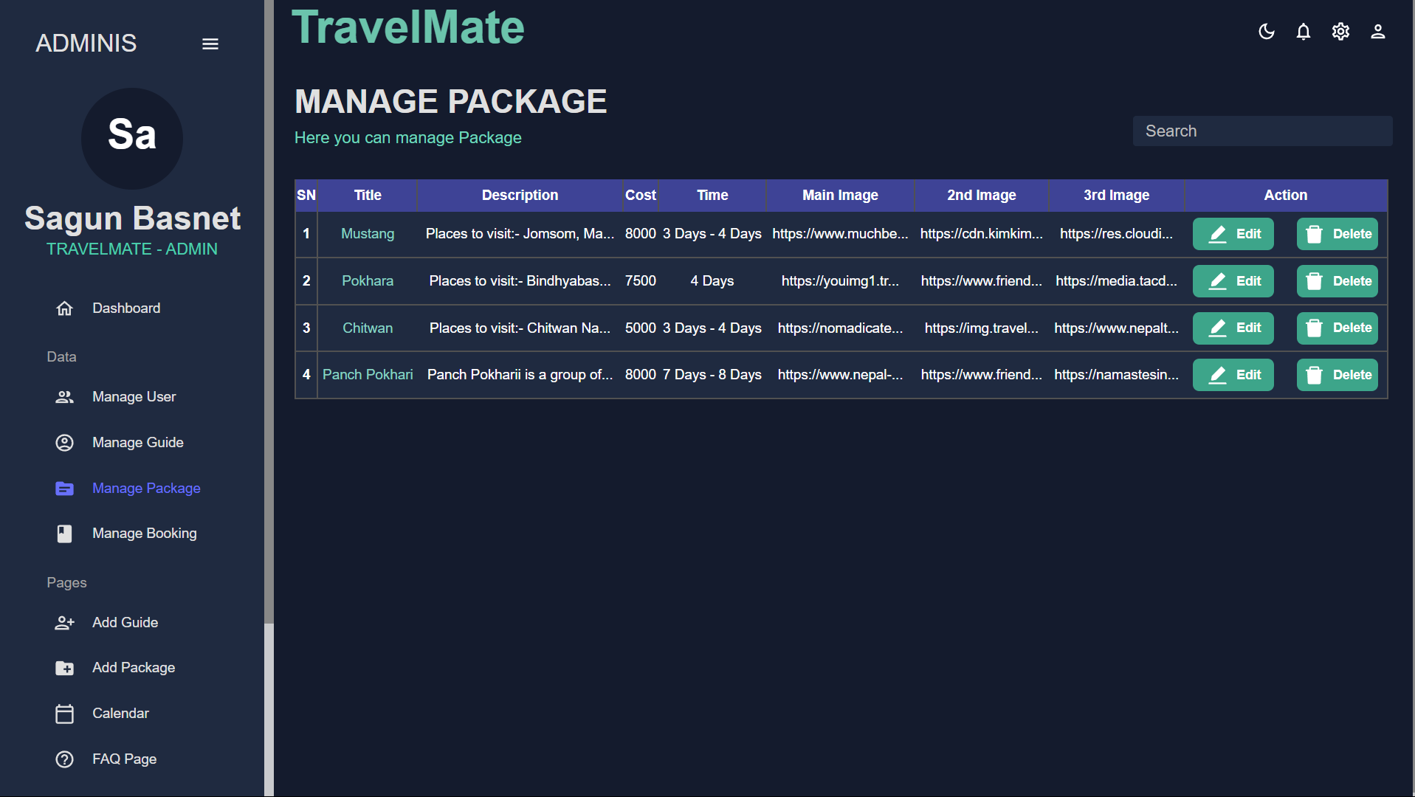

**Figure 3.10.7: Package details page design**

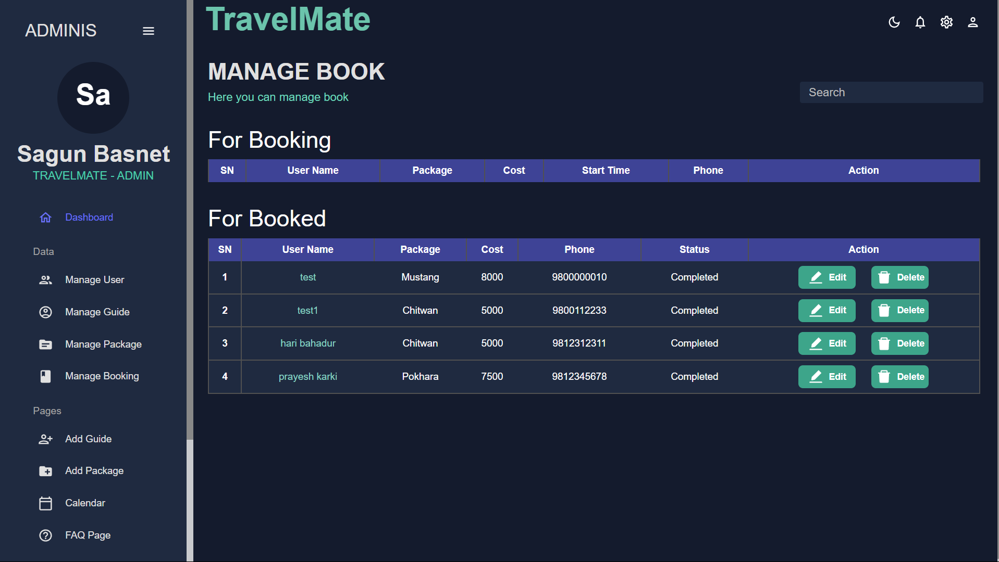

**Figure 3.10.8: Book detail page design**

### 3.2.4 Software Design

**I. Sequence Diagram**

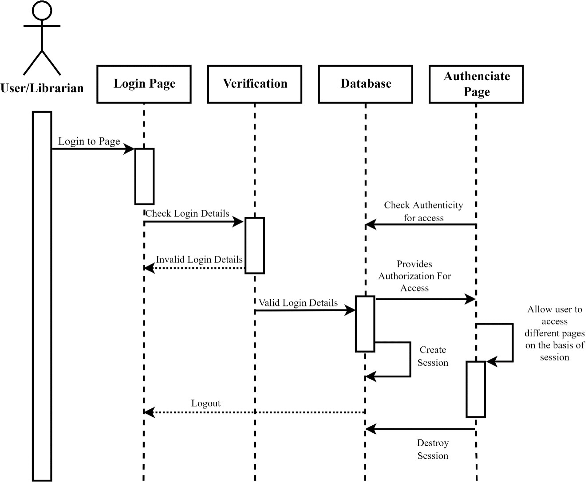

**Tourist/Guide**

**Tourist/Guide**

**Tourist/Guide**

**Tourist/Guide**

**Tourist/Guide**

**Tourist/Guide**

**Tourist/Guide**

**Tourist/Guide**

**Figure 3.11.1: Login sequence diagram**

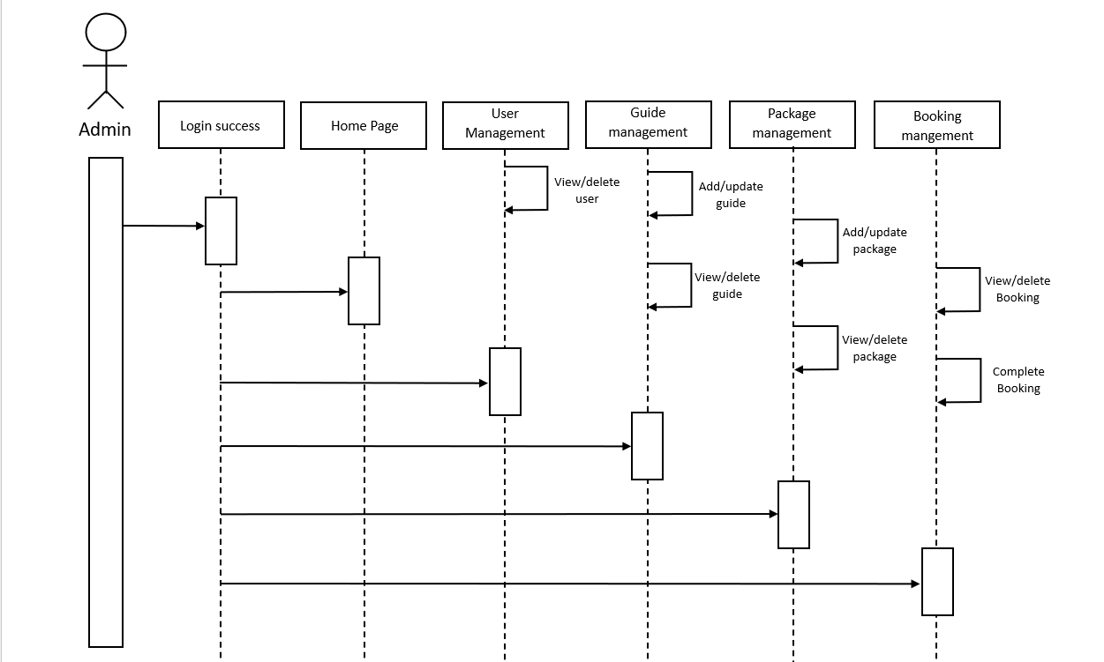

**Figure 3.11.2: Admin sequence diagram**

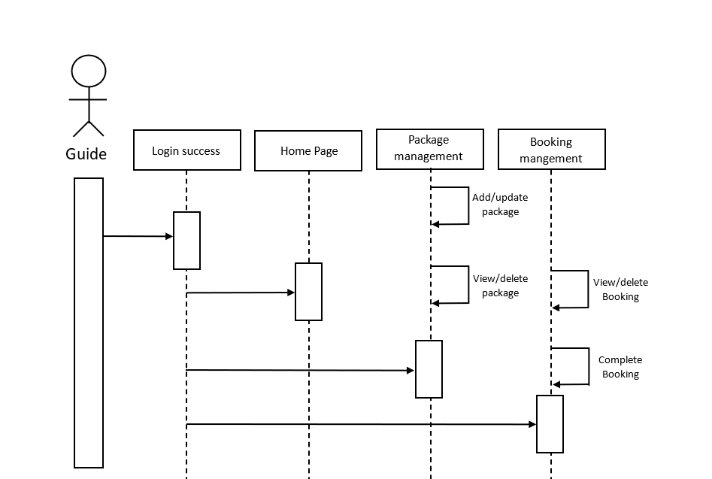

**Figure 3.11.3: Guide sequence diagram**

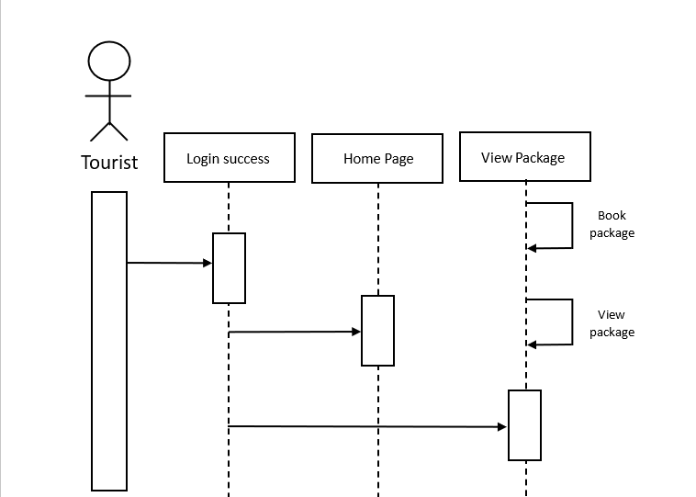

**Figure 3.11.4: Tourist sequence diagram**

**II. Activity Diagram**

Activity diagrams are graphical representations of workflows of stepwise activities and

actionswith support for choice, iteration, and concurrency. Activity diagram is basically a flowchart to represent the flow from one activity to another activity. The activity can be described as an operation of the system.

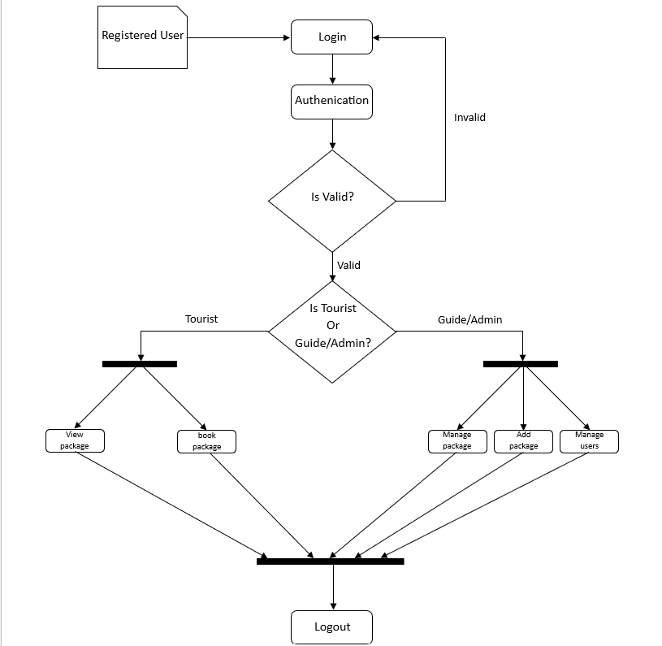

**Figure 3.12: Activity diagram**

# Chapter 4: Implementation and Testing

## 4.1 Implementation

### 4.1.1 Tools Used

The various system tools that have been used in developing both the frontend and the backend of the project are discussed in this chapter.

**I. Frontend**

React.js is used to implement frontend.

React.js: It is an open-source JavaScript library used for building user interfaces (UIs) for web applications. It allows developers to create reusable UI components and efficiently manage the dynamic updating of web pages by using a declarative approach, where they specify how the UI should look based on the application's state and React takes care of updating the UI when the state changes. React is commonly used in combination with other technologies to create interactive and responsive web applications [4].

**I. Backend and Database**

The back end is implemented using Node.js and MySQL database is used.

Node.js: Node.js is an open-source, server-side JavaScript runtime environment that allows developers to execute JavaScript code outside of a web browser. It is designed for building scalable and high-performance network applications, making it particularly well-suited for creating web servers and other backend services. Node.js uses an event-driven, non-blocking I/O model, which makes it efficient and capable of handling many concurrent connections.

MySQL: MySQL is the most popular Open-Source Relational SQL database management system. MySQL is one of the best RDBMS used for developing web-based software applications.

Also, we used other various software like Microsoft Word to create documentation, Google meet for communication, Visual Studio Code as an IDE. We used <https://app.diagrams.net/>website to create different diagrams.

### 4.1.2 Implementation Details of Modules

For building a modern web application, we employ a combination of frontend and backend technologies. React.js, Node.js, and MySQL play pivotal roles in creating a dynamic and interactive web experience.

React.js is a powerful JavaScript library that serves as the cornerstone of our frontend development. It allows us to construct user interfaces with ease. In the frontend realm, React excels at crafting dynamic elements like login forms, tables, and image processing. It operates within web browsers, where it efficiently transforms our code into visually appealing and user-friendly web pages. While HTML provides the structural foundation, React enhances it by enabling us to create reusable UI components and manage state changes seamlessly. By using React, we can build responsive and interactive web applications that provide a superior user experience.

On the backend, we employ Node.js for server-side scripting, harnessing its event-driven, non-blocking I/O model to ensure high performance and scalability. Node.js handles various tasks, including user authentication, data processing, and seamless communication with the MySQL database, which serves as the robust repository for user information, content, and vital data. MySQL facilitates data integrity, security, and structured organization, allowing us to execute SQL queries for data storage, retrieval, and modification, ensuring the smooth and secure operation of our application.

## 4.2 Testing

Software Testing is the process of testing the functionality and correctness of software. Software testing is an empirical technical investigation conducted to provide stakeholders with information about the quality of the product to the context in which it is intended to operate. This includes, but is not limited to, the process of executing a program or application with the intent of finding errors [5].

**Whitebox Testing**

White-box testing is detailed investigation of internal logic and structure of the code.

White-box testing is also called glass testing or open-box testing. To perform white box testing on an application, a tester needs to know the internal working of the code.

**Blackbox Testing**

The technique of testing without having any knowledge of the interior workings of the

application is called black-box testing. The tester is oblivious to the system architecture and does not have access to the source code. Typically, while performing a black-box test, a tester will interact with the system’s user interface by providing inputs and examining outputs without knowing how and where the inputs are worked upon.

### 4.2.1 Test Cases for Unit Testing

Unit testing is a software development process in which the smallest testable parts of an

applications, called units, are individually and independently scrutinized for proper operation. This testing methodology is done during the development process by the software developers and sometimes QA staff. The main objective of unit testing is to isolate written code to test and determine if it works as intended.

Unit testing is an important step in the development process, because if done correctly, it can help detect early flaws in code which may be more difficult to find in later testing stages.

**Test Cases Table 4.1:**

|  |  |  |  |  |  |  |
| --- | --- | --- | --- | --- | --- | --- |
| **TC ID** | **Test Case** | **Test Data** | **Description** | **Expected result** | **Actual Result** | **Remark** |
| 1 | Testing Admin Login | Email:  [superadmin@gmail.com](mailto:superadmin@gmail.com)  Password:  supadmin123 | While entering correct credentials | Sucessfully logged in and redirecr to admin home page | As expected, result | Pass |
| 2 | Testing Admin login | Email:  [superadmin@gmail.com](mailto:superadmin@gmail.com)  Password:  supadmin | While entering incorrect credentials | Show error:  Incorrect email or password | As expected, result | Pass |

|  |  |  |  |  |  |  |
| --- | --- | --- | --- | --- | --- | --- |
| **TC ID** | **Test Case** | **Test Data** | **Description** | **Expected result** | **Actual Result** | **Remark** |
| 3 | Testing Guide Login | Email:  [guidtest@gmail.com](mailto:guidtest@gmail.com)  Password:  123456 | While entering correct credentials | Sucessfully logged in and redirecr to guide home page | As expected, result | Pass |
| 4 | Testing Guide login | Email:  [guidtest@gmail.com](mailto:guidtest@gmail.com)  Password:  Guide123 | While entering incorrect credentials | Show error:  Incorrect email or password | As expected, result | Pass |
| 5 | Testing  Tourist Login | Email:  [test@gmail.com](mailto:test@gmail.com)  Password:  123456 | While entering correct credentials | Sucessfully logged in and redirecr to guide home page | As expected, result | Pass |
| 6 | Testing  Tourist Login | Email:  [test@gmail.com](mailto:test@gmail.com)  Password:  my123456 | While entering incorrect credentials | Show error:  Incorrect email or password | As expected, result | Pass |
| 7 | On clicking logout button | Click Logout button | Clicking logout button | Redirect to home page | As expected, result | Pass |
| 8 | Adding guide by admin | All requered data to create guide | Entering all required guide details | Show message guide added successfully | As expected, result | Pass |
| 9 | Adding new package by admin | All requered data to create package | Entering all required package details | Show message Package added successfully | As expected, result | Pass |
| 10 | Adding new package by guide | All requered data to create package | Entering all required package details | Show message Package added successfully | As expected, result | Pass |
| 11 | Completing the tour while clicking on complete button | Click complete button | Clicking complete button | Move data from booking table to booked table | As expected, result | Pass |

### 4.2.1 Test Cases for System Testing

System Testing includes testing of a fully integrated software system. System testing is

testing conducted on a complete integrated system to evaluate the system's compliance with its specified requirements. All the modules/components are linked together to see whether the system performs as planned. This is crucial for producing high-quality output.

**Test Cases Table 4.2:**

|  |  |  |  |  |  |  |
| --- | --- | --- | --- | --- | --- | --- |
| **TC ID** | **Test Case** | **Test Data** | **Description** | **Expected result** | **Actual Result** | **Remark** |
| 1 | Booking package by tourist | Package id: 2  User id: 5 | Viewing package and clicking book button | Display booking details | As expected, result | Pass |
| 2 | Canceling booked package by tourist | Package id: 2  User id: 5 | Clicking on cancel button of booked package | Package booking canceled | As expected, result | Pass |
| 3 | Trying to book already booked package | Package id: 3  User id: 2 | Viewing package but not able to book package | This package is already booked please try again later | As expected, result | Pass |

# Chapter 5: Conclusion and Future work

## 5.1 Lesson Learnt / Outcome

This project focuses on developing a software that assists in managing library in efficient

and convenient way. This project focuses on developing a web app that can be used to manage and keep track of book and library members. It is going to help the librarian to manage library data easily. This Library Management System is going to help traditional library management techniques be digitalized.

## 5.2 Conclusion

This software provides a computerized version of a library management system which will be beneficial to the library. Librarian will get relief from traditional data/record system. With the development of this LMS, librarian as well as library members will be benefited. It will save a lot of time as record keeping will be easier and efficient, transaction can be completed within short period of time. Data and information retrieval will be faster.

## 5.3 Future Recommendations

We intend to develop this software further and enhance it to make it more productive. Possible future enhancement of this LMS would be:

· Adding QR code-based system for Issue/Return of books

· Adding feature for the members to reserve available books online · Improvements on UI and other features

# References

|  |  |
| --- | --- |
| [1] | "Expedia.com," Expedia Group, Inc., 22 10 1996. [Online]. Available: https://www.expedia.com/stories/expedia-com-expedia-and-hotels-com-direct-connect-technology-saves-time-and-money-for-more-than-a-thousand-hotel-partners/. [Accessed 25 4 2023]. |
| [2] | "tutorialspoint.com," 6 9 2006. [Online]. Available: https://www.tutorialspoint.com/sdlc/sdlc_waterfall_model.htm. [Accessed 3 5 2023]. |
| [3] | "wikipedia," 15 1 2001. [Online]. Available: https://en.wikipedia.org/wiki/Database_schema. [Accessed 1 6 2023]. |
| [4] | "freecodecamp," 14 10 2014. [Online]. Available: https://www.freecodecamp.org/news/how-to-create-a-react-app-with-a-node-backend-the-complete-guide/. [Accessed 10 7 2023]. |
| [5] | "Google," 4 9 1998. [Online]. Available: https://www.google.com. [Accessed 10 4 2023]. |

# Appendices

## Appendix 1: Screenshots



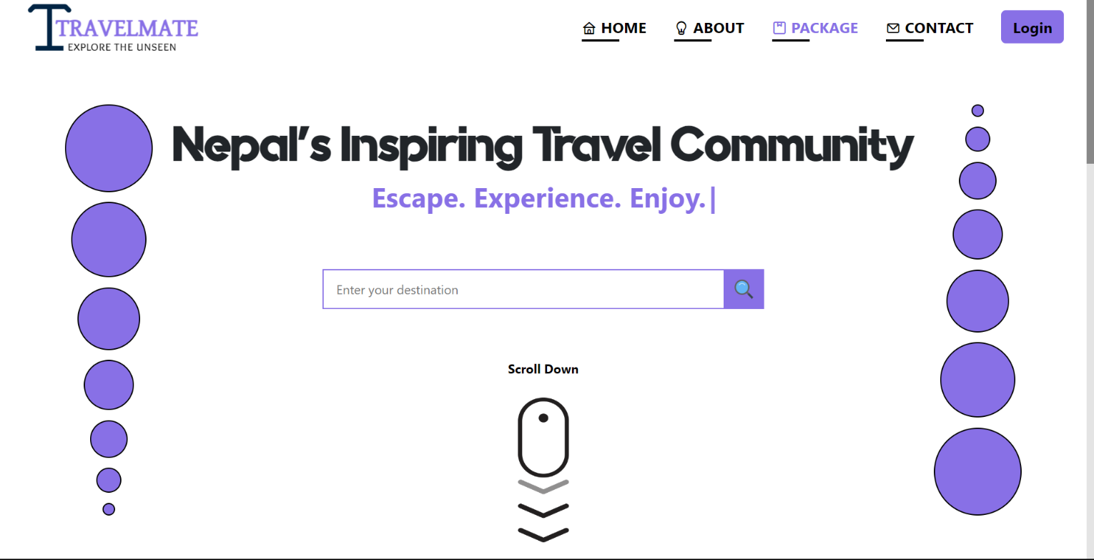

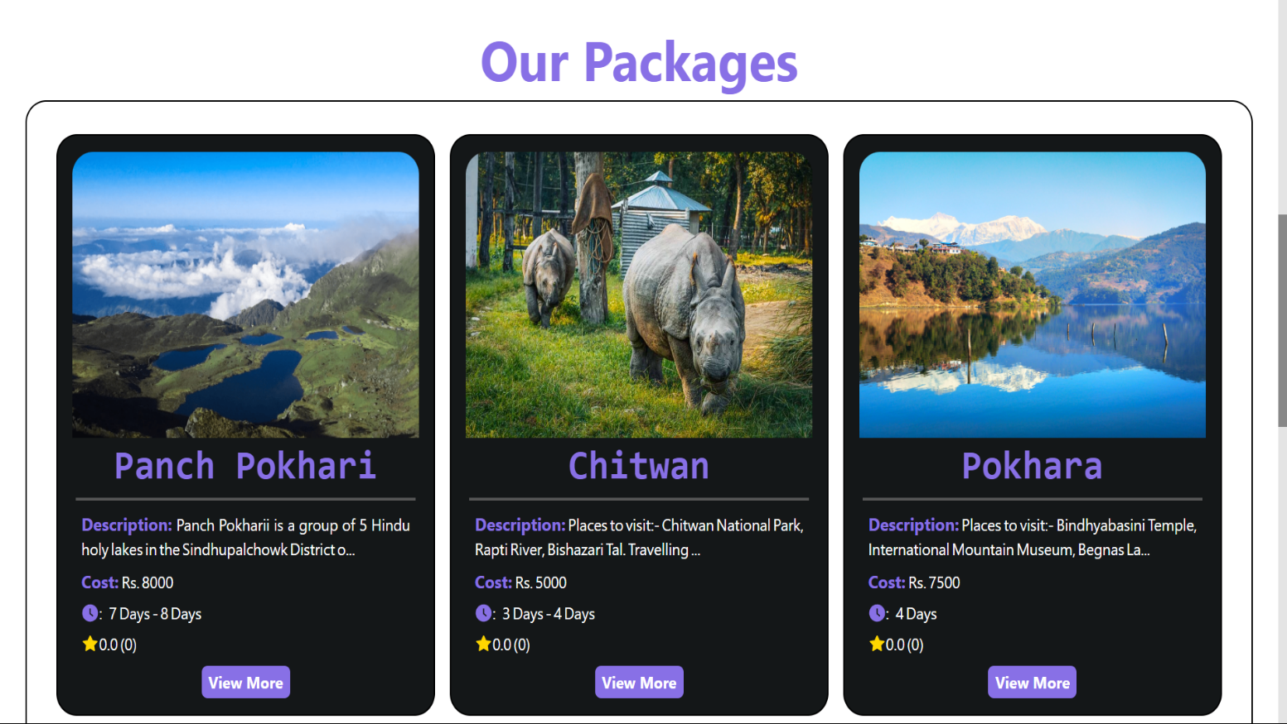

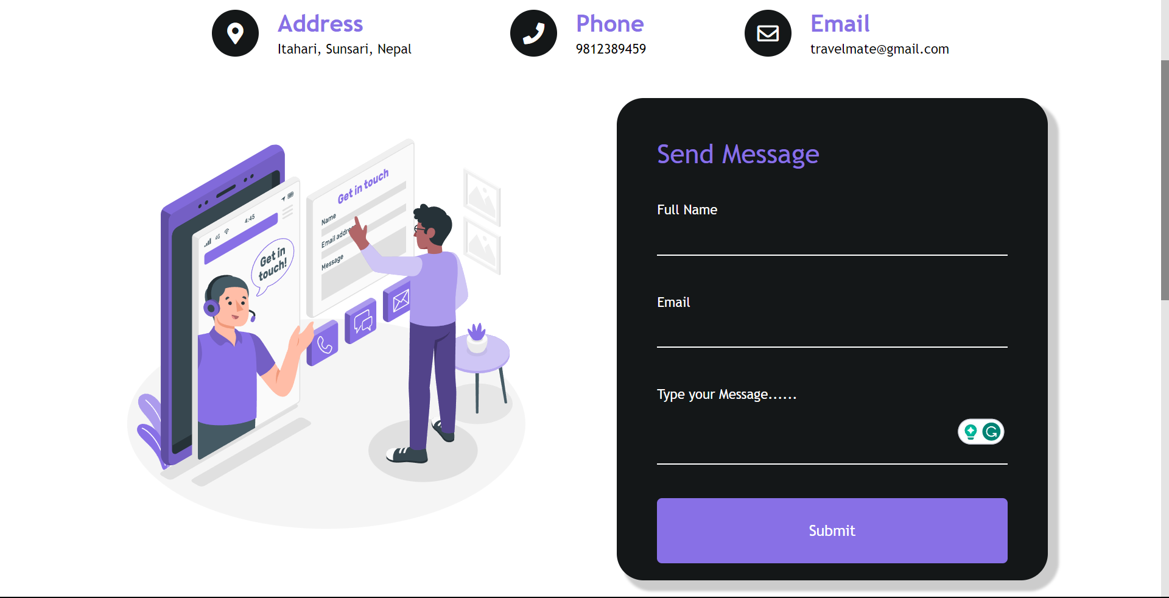

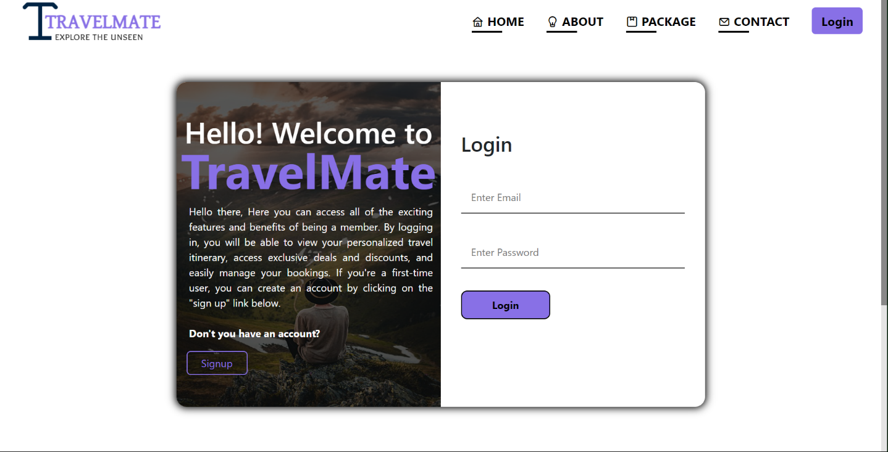

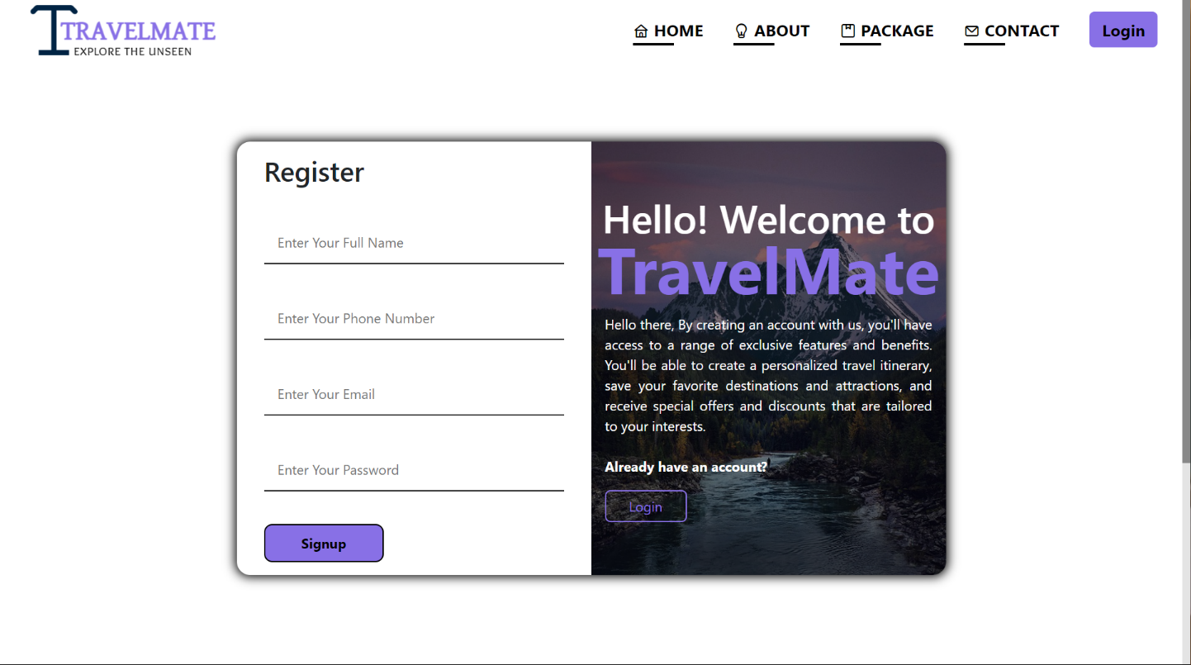

## Appendix 2: Source Codes

**Login page source code:**

**Frontend:**

import React, { useContext, useState } from 'react';

import { useFormik } from 'formik';

// import axios from "axios";

import { Link, useNavigate } from 'react-router-dom';

import { signUpSchema } from '../../schemas';

import { AuthContext } from '../../context/authContext';

const initialValues = {

email: "",

password: "",

}

export default function LoginContent() {

const [inputs, setInputs] = useState({});

const [err, setErr] = useState(null);

const navigate = useNavigate();

const {login} = useContext(AuthContext);

const handleMyChange = (e) =>{

setInputs(prev=>({...prev, [e.target.name]: e.target.value}))

}

const handleClick = async e =>{

e.preventDefault();

try{

await login(inputs)

navigate("/");

}catch(err){

setErr(err.response.data);

}

}

const {values, errors, touched, handleBlur, handleSubmit, handleChange } = useFormik({

initialValues: initialValues,

validationSchema: signUpSchema,

onSubmit: (values) => {

setInputs({

email: values.email,

password: values.password,

});

// console.log(values);

},

});

return (

<div className='loginMainDiv'>

<div className="loginDiv">

<div className="left">

<div className="imgDiv">

<div className="dark">

<h2>Hello! Welcome to</h2>

<h1>TravelMate</h1>

<p>Hello there, Here you can access all of the exciting features and benefits of being a member. By logging in, you will be able to view your personalized travel itinerary, access exclusive deals and discounts, and easily manage your bookings. If you're a first-time user, you can create an account by clicking on the "sign up" link below. <br /> <br />

<span>Don't you have an account?</span>

</p>

<div className="regBtns">

<Link to="/signup">

<button className='regBtn'>Signup</button>

</Link>

</div>

</div>

</div>

</div>

<div className="right">

<h2>Login</h2>

<form action="" onSubmit={handleSubmit}>

<input type="email" placeholder='Enter Email' name='email' onChange={(e) =>{

handleChange(e);

handleMyChange(e);

}} onBlur={handleBlur} value={values.email}/>

<span className='loginErrorMessage'>

{errors.email && touched.email ? (errors.email) : null}

</span>

<input type="password" placeholder='Enter Password' name='password' onChange={(e) =>{

handleChange(e);

handleMyChange(e);

}} onBlur={handleBlur} value={values.password}/>

<span className='loginErrorMessage'>

{errors.password && touched.password ? (errors.password) : null}

</span>

<input type="submit" value='Login' onClick={handleClick}/>

<span className='incorrectError'>{err && <h6> {err}</h6>}</span>

</form>

</div>

</div>

</div>

)

}

**Backend:**

export const login = (req, res) => {

//check user exist or not...

const q = "select * from user where email = ?";

//excute query...

db.query(q, [req.body.email], (err, data) => {

if (err) return res.json(err);

//if there is no user..

if (data.length === 0) return res.status(404).json("User not found!");

//if user exist..

//check password

const isPasswordCorrect = bcrypt.compareSync(

req.body.password,

data[0].password

);

//if not correct..

if (!isPasswordCorrect)

return res.status(400).json("Wrong email or password");

const token = jwt.sign({ id: data[0].id }, "jwtkey");

//getting password and other user information sepratly

const { password, ...other } = data[0];

res

.cookie("access_token", token, {

httpOnly: true,

})

.status(200)

.json(other);

});

};

**Home page source code:**

import React from 'react'

import PropTypes from "prop-types";

export default function HomeImgDivs(props) {

// let mar = props.ani;

return (

<div className={props.class}

>

<div className="image-overlay">

<h1>{props.heading}</h1>

</div>

</div>

)

}

HomeImgDivs.propType = {

class: PropTypes.string,

heading: PropTypes.string,

ani: PropTypes.number

};

import React from 'react'

import PropTypes from "prop-types";

import MySLIDER from './slider/MySLIDER'

export default function HomeSliders(props) {

return (

<section className="homeSlider" id='recently'>

<h1>{props.heading}</h1>

<p>

Lorem ipsum dolor sit amet, consectetur adipisicing elit. Autem

inventore alias nemo optio et officia velit natus ipsa consequatur

saepe. Lorem ipsum dolor sit, amet consectetur adipisicing elit. Eveniet

ipsam inventore magni repudiandae deserunt, quod numquam eum odio rerum

nulla.

</p>

<div className='mainSlider'>

<MySLIDER />

</div>

</section>

)

}

HomeSliders.propType = {

heading: PropTypes.string

};

import './home.css';

import React from 'react';

import PoolImg from '../../img/pool.avif'

import HomeImgDivs from './HomeImgDivs';

import BackImg from './BackImg';

import HomeSliders from './HomeSliders';

import cloud1 from '../../img/Cloud-PNG-2.png';

import cloud2 from '../../img/Cloud-PNG-9.png';

import cloud3 from '../../img/Cloud-PNG-10.png';

import cloud4 from '../../img/Cloud-PNG-12.png';

import Ballon1 from '../../img/balloon1.avif'

import Ballon2 from '../../img/balloon2.avif'

import OtherPageLink from './OtherPageLink';

export default function MainContent() {

return (

<div>

<div className="mainBody">

<div className="cloud">

<img src={cloud1} alt="" style={{"--i":"1"}}/>

<img src={cloud3} alt="" style={{"--i":"2"}}/>

<img src={cloud2} alt="" style={{"--i":"3"}}/>

<img src={cloud4} alt="" style={{"--i":"4"}}/>

<img src={cloud1} alt="" style={{"--i":"5"}}/>

<img src={cloud2} alt="" style={{"--i":"6"}}/>

<img src={cloud4} alt="" style={{"--i":"7"}}/>

</div>

<div className="ballon1">

<img src={Ballon1} alt="" />

</div>

<HomeImgDivs class="mainImgDiv indonesia" heading="D"

/>

<HomeImgDivs class="mainImgDiv france" heading="R"

/>

<HomeImgDivs class="mainImgDiv spain" heading="E"/>

<HomeImgDivs class="mainImgDiv nepal" heading="A"/>

<HomeImgDivs class="mainImgDiv germany" heading="M"/>

</div>

<div className="ballon2">

<img src={Ballon2} alt="" />

</div>

<div className="pool">

<img src={PoolImg} alt="" />

</div>

< OtherPageLink/>

<BackImg/>

<div className="">

<HomeSliders heading="Popular packages"/>

<HomeSliders heading="Recent packages"/>

{/* <MySLIDER/> */}

</div>

</div>

)

}

import React from 'react'

import './home.css';

import gettingStarted from '../../img/gettingStarted.svg'

import homeAbout from '../../img/homeAbout.svg'

import homePackage from '../../img/homePackage.svg'

import { NavLink } from 'react-router-dom'

export default function OtherPageLink() {

return (

<div>

<div className="mainCardContainer">

<NavLink className='homeLinks' to="/signup">

<div className="infoCard card1">

<h2>Getting Started</h2>

<img src={gettingStarted} alt="" />

</div>

</NavLink>

<NavLink className='homeLinks' to="/about">

<div className="infoCard card2">

<h2>About Us</h2>

<img src={homeAbout} alt="" />

</div>

</NavLink>

<NavLink className='homeLinks' to="/package">

<div className="infoCard card3">

<h2>Our plans/packages</h2>

<img src={homePackage} alt="" />

</div>

</NavLink>

</div>

</div>

)

}

import React from "react";

import PropTypes from "prop-types";

import { Link } from "react-router-dom";

export default function SliderCard(props) {

return (

<div style={{height: "100%"}}>

<div className="sliderContent">

<div className="cardImg">

<img

src={props.source}

alt=""

/>

<div className="black" />

</div>

<div className="cardInfo">

<h2>{props.place}</h2>

<Link to="/package">

<button className="btn">view</button>

</Link>

</div>

</div>

</div>

);

}

SliderCard.propType = {

place: PropTypes.string,

source: PropTypes.string

};

**Booking source code:**

import { db } from "../db.js";

export const bookDetail = (req, res) => {

const { id, productId, cost, sqlFormattedDate } = req.body;

// Create a SQL query to insert the data into the booking table

const sql = `

INSERT INTO booking (user_id, pac_id, amount, start_date)

VALUES (${id}, ${productId}, ${cost}, '${sqlFormattedDate}')

`;

// Execute the query with the provided data

db.query(sql, (err, result) => {

// console.log("Database result:", result);

if (err) {

console.error("Error inserting data:", err);

res.status(500).json({ error: "An error occurred", details: err.message });

} else {

console.log("Data inserted successfully");

res.json({ message: "Payment successful" });

}

});

};

## Appendix 3: Database Table

**Table 1: User**

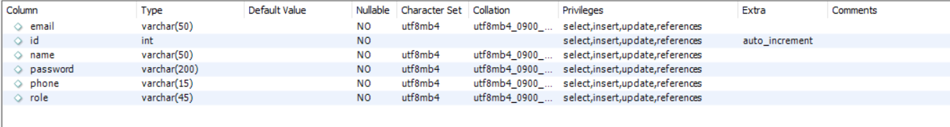

**Table 2: Package**

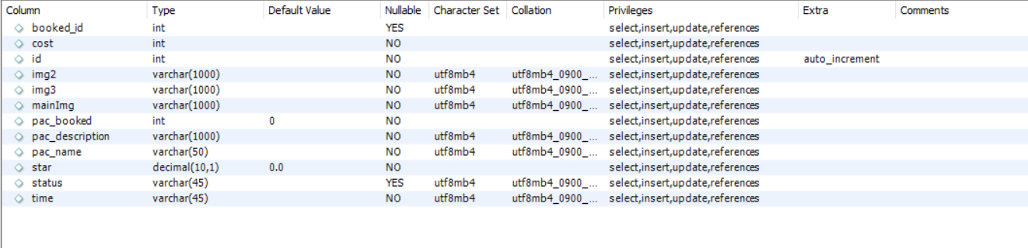

**Table 3: booking**

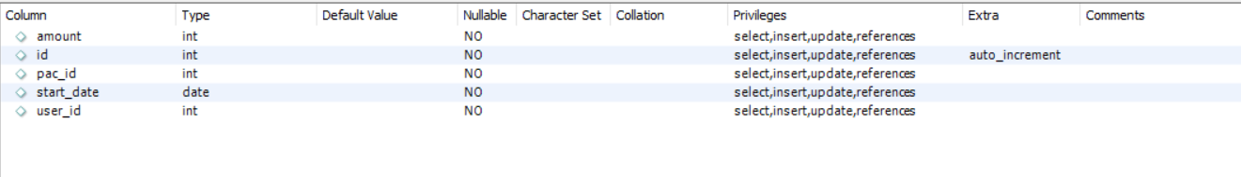

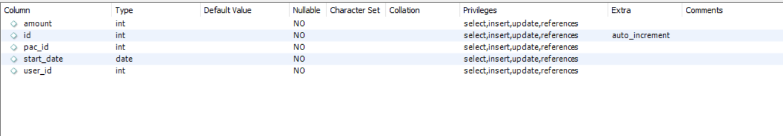**Table 4: booked**

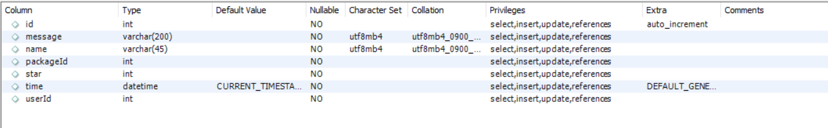**Table 5: Review**